**Bigdata Assignment 4.4**

Perform incremental load in Hive.Read from MySQL Table and load it in Hive table.Create hive table if it does not exist.If it exists, perform the incremental load.

Solution -

* Created a database 'acadgild' and inside it a table 'student' where 5 records where inserted

**create database acadgild;**

**use acadgild;**

**create table student (id int , name varchar(20) , city varchar(20));**

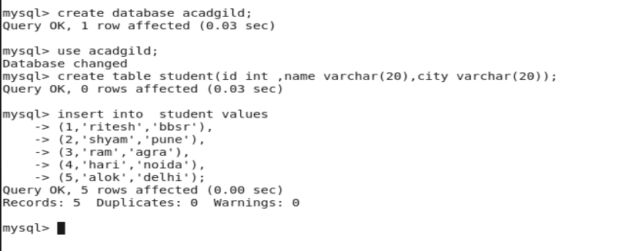

* Checked the contensts of the table.

**select * from student;**

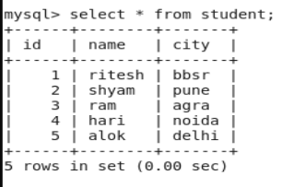

* In hive , we checked the default database , no tudent table exists.

**show databases;**

**show tables;**

* We transferred the data from mysql to hive using sqoop.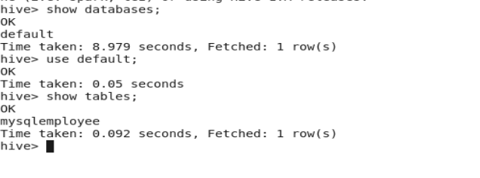

**sqoop import –connect jdbc:mysql://localhost/acadgild –username root –password** [**Root@123**](mailto:Root@123) **–table student -m 1 –target-dir /sqoopouthive –hive-import**

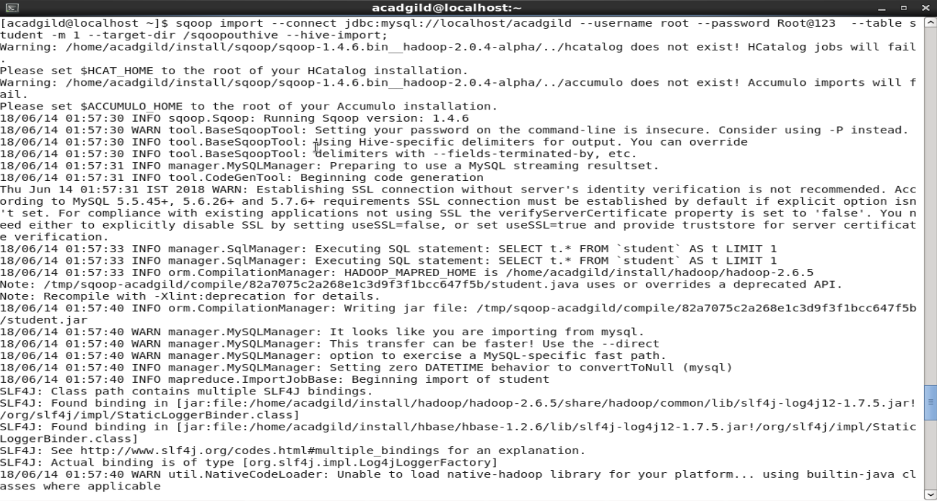

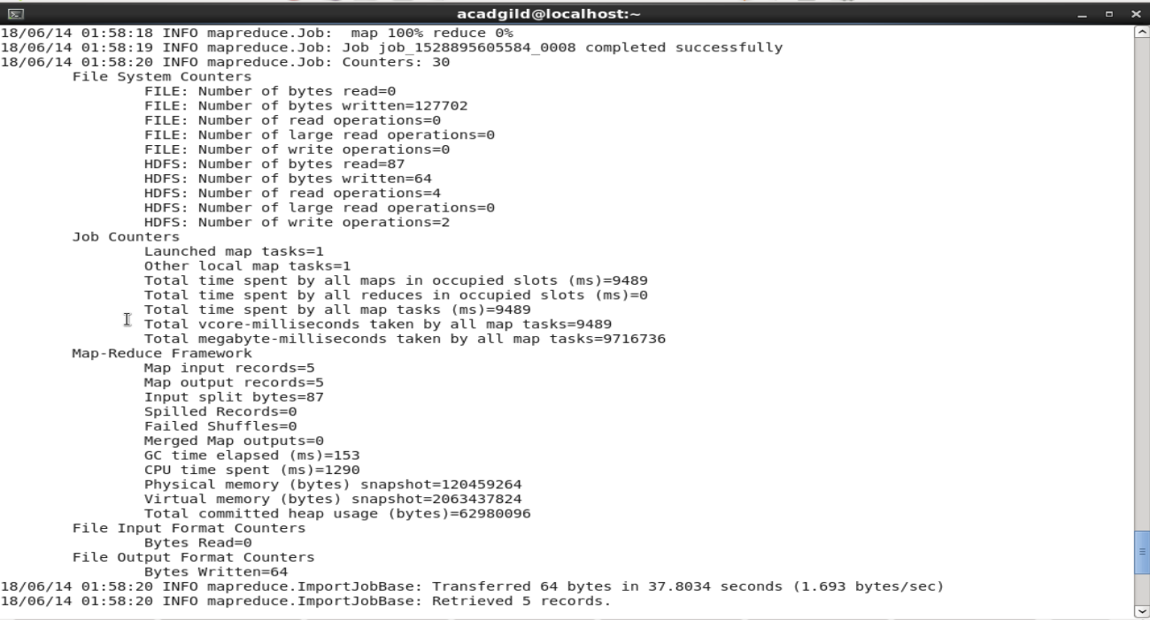

* Then , in hive we checked the content of student

**select * from student;**

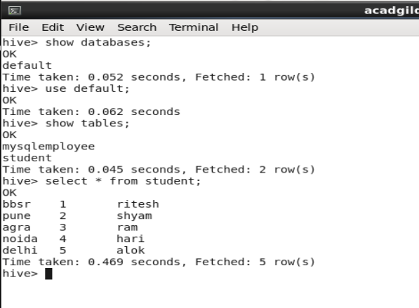

* Now , we added 2 records in the student table in mysql . Then checked its contents

**select * from student;**

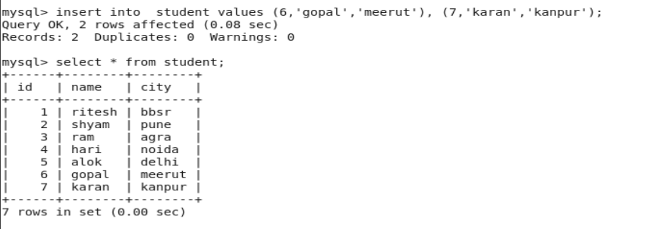

* Then we performed the incremental load by using sqoop incremental

**sqoop import –connect jdbc:mysql//localhost/acadgild –username root –password** [**Root@123**](mailto:Root@123) **–table student –check-column id –incremental append –last-value 5 -m 1 –target-dir /sqooputhive;**

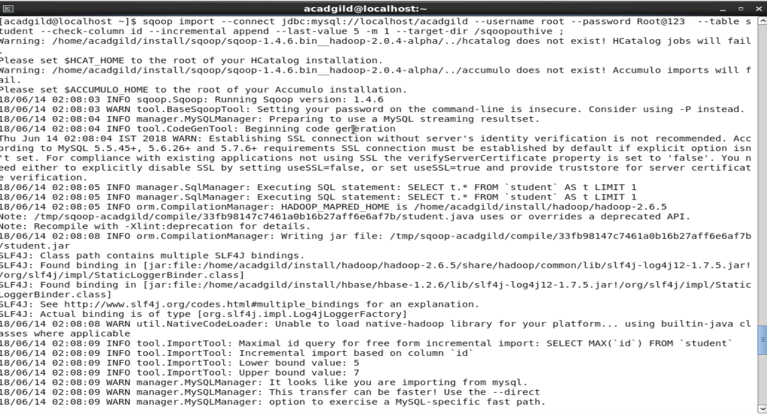

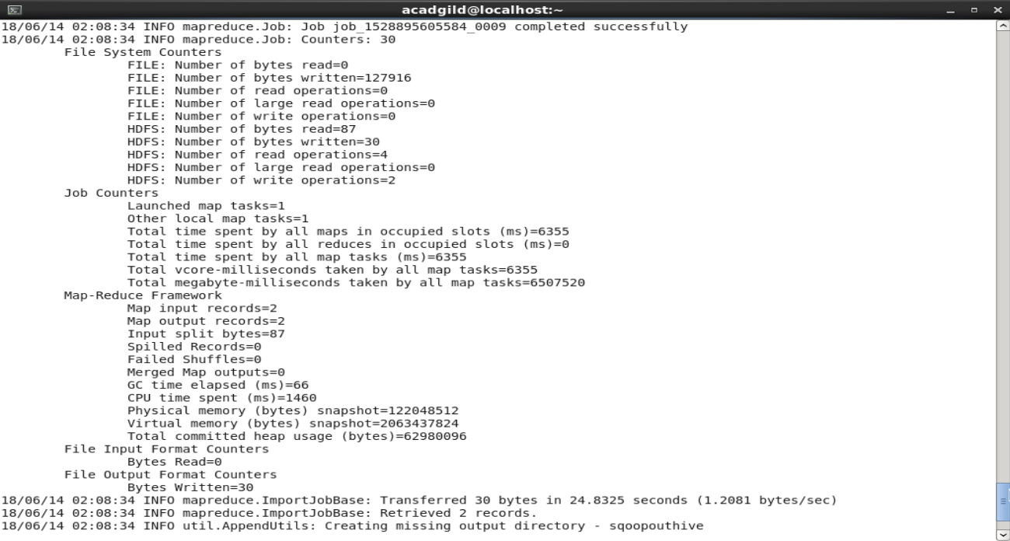

* In hive , we checked the content of the table after incremental load

**select * from student;**

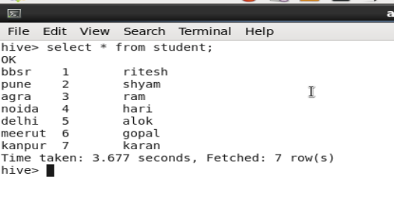

The data is same as in the mysql after updating 2 records.